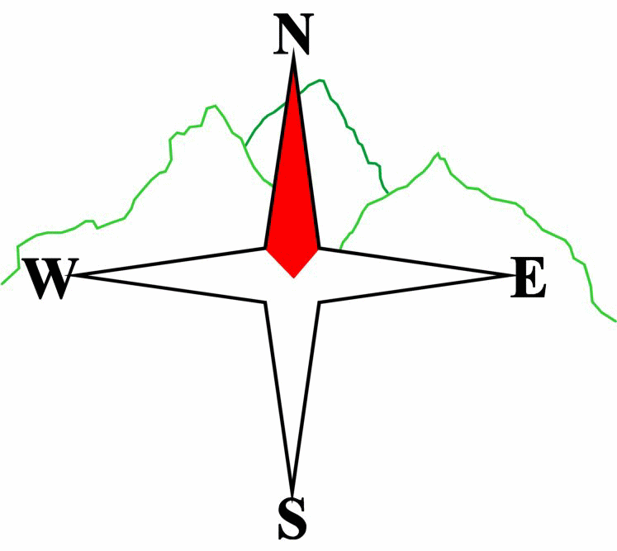***Blairgowrie & District Hillwalking Club***

**www.bdhc.org.uk**

Meall Chuaich, East Drumochter

24/03/2024

**O.S. Map No**: 42

|  |  |  |  |  |
| --- | --- | --- | --- | --- |
| **Bus times:** | **Blairgowrie** (**Wellmeadow**): **08:00** | | **Alyth** (**Square**): **07:45** | |
|  | **Other: Dunkeld: Time TBA** | | | |
|  | | | | |
|  | | | | |
| A Walk – Meall Chuaich | | | | |
| Start – Layby 94 on A9. A, B & C walks – Start walking N on verge to reach gate at NN 654 867. Follow track to aqueduct. Head E along track and cross bridge. Carry on in easterly direction for 1.5Kms. Then take track on right crossing the Allt Coire Chuaich. Shortly after, take the track heading up the shoulder of Stac Meall Chuaich. Carry on until the gradient eases and head east to reach the summit of Meall Chuaich (M 951m) Return via outward route. | | | | |
| Approx. distance: 15 km | | Total ascent: 600 m | | Min. **walking** time: 4¾ hrs |
|  | | | | |
| B Walk – Carn na Caim | | | | |
| Route as A walk to second bridge. Take right track after bridge, continue on track to point 674 856 where track splits, take the left fork SE up onto the shoulder of Carn na Caim. Follow this to reach its summit (M 941 m). Head N down shoulder to once again reach point 674 856 then follow outward track back to start. | | | | |
|  | | | | |
| Approx. distance: 17 km | | Total ascent: 590 m | | Min. **walking** time: 5¼ hrs |
|  | | | | |
| C Walk – Leacainn | | | | |
| Route as B Walk to fork in track at 674 856, take the right fork and head SW for app 1km then head W to point 437m. From there head NW to reach the summit of Leacainn. Head in northerly direction to 656 864, cross aqueduct and back to start. | | | | |
| Approx. distance: 9 km | | Total ascent: 240 m | | Min. **walking** time: 3½ hrs (at 3 kph) |

|  |  |
| --- | --- |
| IMPORTANT: YOUR SAFETY IN THE HILLS | |
| **The Committee reminds members and guests of the following important points:** | |
| * You are responsible for your own safety * Club officials are not trained mountain leaders * Are you fit enough to complete your chosen walk in the available time? * Know where you are going on the walk and follow the route on your map. * Know how many are in your party and stay together | * Ensure you have enough food plus emergency rations * Carry a map & compass, survival bag, torch, whistle and small first aid kit. Know how to use them. * In winter conditions you must carry an ice axe on high level walks (club rule). You are also recommended to carry crampons. * **Learn** how to use your equipment. |
|
|
|
|
|  |
| **Club officials will be happy to give advice on any of these points if requested.** | |

The next club walk is on the **21st April** to **An Caisteal** starting at 07:30 (Blairgowrie) and 07:15 (Alyth)

.

Other information/events: **11-13 May** Weekend meet - **Lake District**

**Please note that the Minimum walking times are based on reasonably fast walkers and assuming good conditions. The times do not include stops or breaks.**

## **In poor weather conditions or if members are not comfortable walking at 4km/hour then alternative or shorter routes should be considered.**